Digital heroes
Elementary school and Kindergarten, Višňové, Znojmo district,
funded organisation
Višňové 228, 671 38 Višňové
Jiří Beran, Ilona Hůrková
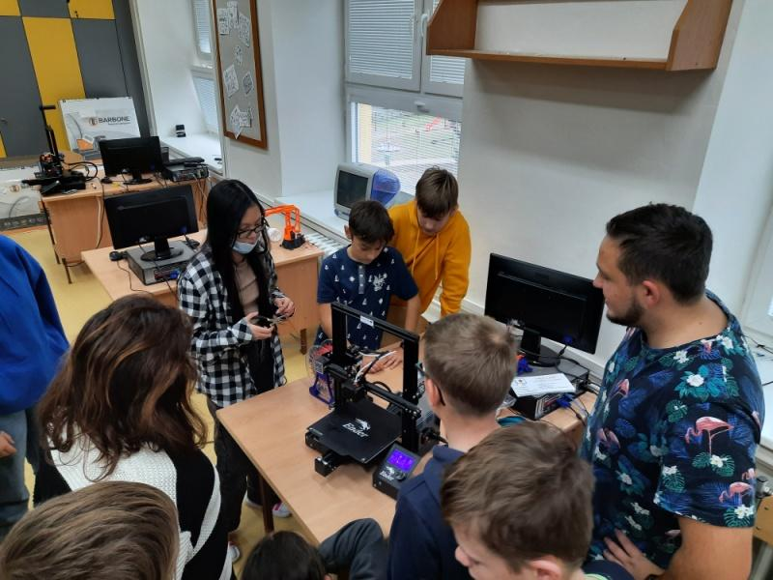
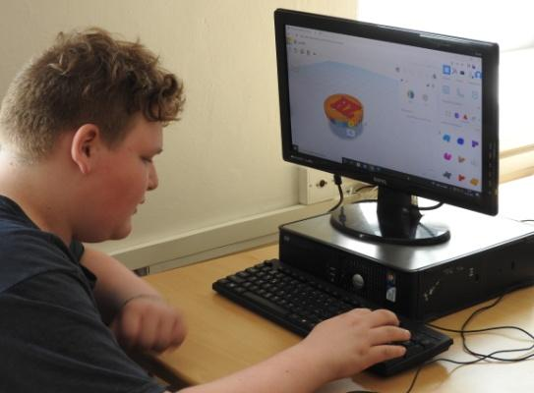
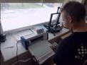

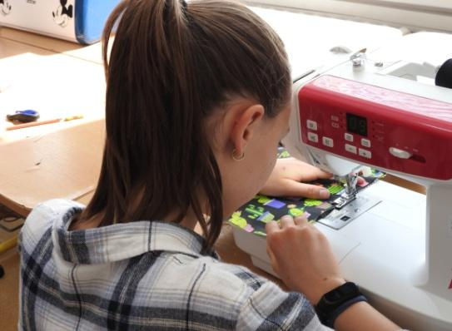

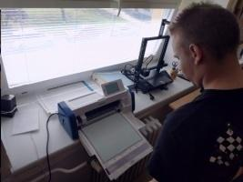
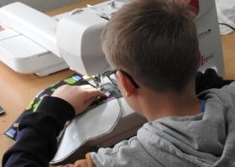

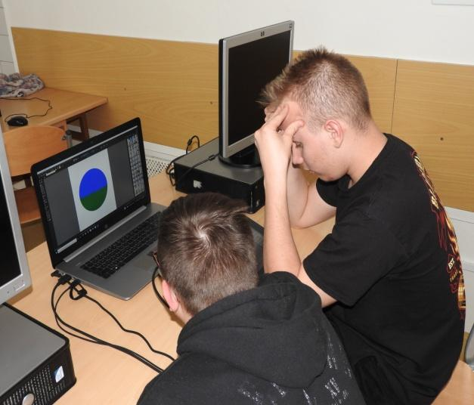
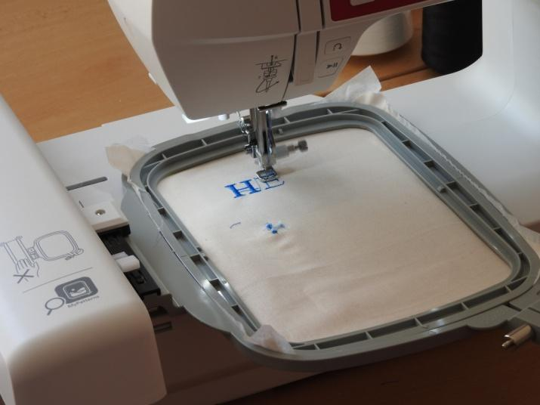

Contents:
Project information 4
Project description 4
Age composition of pupils 4
Skills that students should master, abilities that they should have 4
Skills that pupils will acquire 4
Material equipment needed to implement the project 5
Devices 5
Consumables 5
Financial complexity of the project 6
Consumables 6
Time schedule 7
Recommended group size 7
Description of individual steps 7
Familiarization with the digital workshop and the possibilities of individual devices 7
Motivating students, generating cultivation of ideas 9
Prototype production (without the use of technology) 11
Problem solving – how to incorporate advanced digital technologies into production to increase work efficiency and product attractiveness 23
Editing design – CanvasWorkspace environment 25
Cutting plotter - scanning cut, cutting fabric and canvas 27
Graphics tablet – embroidery design in the EZDesign program 28
3D printer - button design in Tinkercad environment, slicing in PrusaSlicer, custom printing 30
Final product 32
Theoretical background for the implementation of the project 33
List of links to study materials and resources used 34
Project outputs 35
Links to the project presentation – articles from the school website 35
Summary of work 36

Project information

Project description
In the project, the students solved a problem (concentration idea): Whether and how modern technologies can help ensure the sustainability of human activity and contribute to environmental education not only in schools. Specifically, the students focused on reducing the amount of single-use plastics (microthin bags) that school students use to pack snacks. The students designed a prototype of a snack bag and using digital technologies, suggested how to make its production more efficient and make the design more attractive. They also created the school eco-label "HERO ZERO".

Age composition of pupils
Due to the difficulty of operating the digital technologies used (plotter, sewing machine, etc.), we recommend implementing the project with 2nd grade students. We worked with 7th-9th grade students.

Skills that students should master, abilities that they should have
- the ability to generate and cultivate ideas,
- problem solving,
- team work,
- motivation to learn new things and complete a task,
- basics of digital literacy (working with a PC, graphic programs, ...).

Skills that pupils will acquire
- modelling 3D objects in the Tinkercad environment,
- preparation of models for 3D printing (slicing),
- working with a 3D printer,
- work with graphics tablet and Krita editor
- working with a cutting plotter and creating designs in the CanvasWorkspace environment,
- working with a programmable sewing machine and creating embroidery in the EZDesign and MyPatterns applications,
- thinking in the context of sustainability.

Material equipment needed to implement the project

Devices
- graphics tablets,
- programmable sewing and embroidery machine,
- cutting plotter,
- notebooks,
- external backup disk.

Consumables
- various types of cotton canvases - plain for embroidery or printed, e.g.: https://www.mojelatky.cz/Jarni-venkov-d67205.htm
- waterproof food fabric with PUL coating: https://www.tiki-mechulka.cz/Nepromokava-potravinova-tkanina-s-PUL-zaterem-d2865.htm
- top embroidery thread: https://www.nej-sici-stroje.cz/prislusenstvi-k-sicim-strojum/nite/zakladni-sada-30-vysivacich-niti/
- lower embroidery thread: https://www.nej-sici-stroje.cz/spodni-nit-vysivani/
- PLA filament: https://www.prusa3d.com/cs/produkt/perlova-zelena-pla-tiskova-struna-filament-1kg/

Financial complexity of the project
The biggest financial burden is the acquisition of equipment used in the design and production of the final product. We received them as part of the project in the total amount of approx. 90 000 CZK.
As for the consumables required for the production of 1 piece of the final product, the composition of the costs is as follows.

Consumables
Cotton canvas approx. 0.1 m2 | 7 CZK
Waterproof food grade fabric | 27 CZK
Threads, embroidery and sewing | 3 CZK
PLA filament 1.3 g | 1 CZK
Total cost for 1 pocket | 38 CZK

Note: Adhesive pads, which are accessories of the cutting plotter, can also be considered consumables. The pad can be used approx. 50–100 times depending on the type of material. The price of one pad is 580 CZK, the financial burden can be reduced by using the so-called: intermediate pads at a price of 78 CZK/pc.
At the same time, it should be noted that some types of material must be purchased in the minimum possible quantity, e.g. filament 1 kg for the price of CZK 690, which increases the financial requirements for consumables to start the project.

Time schedule
The entire project is suitable for the timetable of one school year, for example 1 hour per week, as part of an optional subject. The project has several phases: familiarisation with the equipment of the digital workshop and the possibilities of individual devices, student motivation, generation and cultivation of ideas, production of a prototype of a snack bag without the use of technology, problem solving - how to incorporate advanced digital technologies into production to increase work efficiency and product attractiveness.

Recommended group size
Due to the higher demands on the acquisition of new skills and their application, it is advisable to work with a smaller group of about 10 students, or with the use of tandem teaching (2 teachers per class or group).

Description of individual steps

Familiarisation with the digital workshop and the possibilities of individual devices
At the beginning of the student project, the students will familiarise themselves with what they will have at their disposal for its implementation – the equipment of the digital workshop - it is ideal for them to participate in its commissioning (unpacking, distribution, ...). If the digital workshop is already part of the school, then it is necessary for them to familiarise themselves with the possibilities offered by each device, while pupils can work in the following successive steps:
3d Printer
- download .STL file from https://www.thingiverse.com/
- file preparation for printing = slicing in a program, e.g.: PrusaSlicer – G-CODE file
- basics of working with a printer, filament replacement
- printing the item
- nameplate design in https://www.tinkercad.com/
- name tag printing
Graphic tablet
- familiarisation with the functions of the graphic tablet
- familiarisation with the possibilities of the Krita program
- creating a personal logo
- save to external disk in .PNG, .JPEG format
Cutting plotter
- download the file in. FCM format from the database https://canvasworkspace.brother.com/
- the basics of working with a plotter, starting up, preparing the material and gluing it to the mat, uploading the file
- cutting or scanning
- name template design in https://canvasworkspace.brother.com/
- cutting out the template
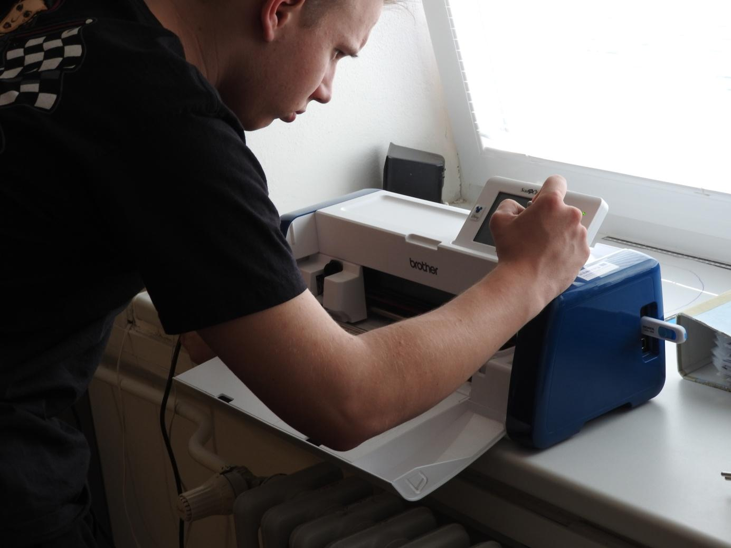
Programmable embroidery and sewing machine
- basics of working with a machine, changing and threading threads, changing stitches, simple sewing
- hemming the napkin
- replacing the embroidery module, fixing the fabric in the embroidery frame
- creating text, selecting a motif in the MyPatterns application and transferring data to the sewing machine
- custom embroidery
- creating a personal logo using a graphics tablet and the EZDesign program
- stitch settings and embroidering simulation
Note: It is not a condition that all students are specialists in all devices, but it is true that the essence of their operation is often similar. Individual steps are recommendations and some can be skipped or omitted.

Motivating students, generating cultivation of ideas
Students should be motivated by means of educational videos or presentations that affect the following topics: single-use plastic production, recycling problems, microplastic pollution, etc. The following are questions to ponder: How to prevent this disaster? How do you personally, your family, your school participate in the production and consumption of single-use plastics? What can we do here and now? ... Subsequently, the students generate ideas using brainstorming or brainwriting methods and agree on the one that will be implemented. The teacher can appropriately, but if possible very non-violently correct the direction in which the thinking is going. Cultivating the idea consists in planning how to realise the given thing, in this case making the pocket (material, tools, other tools, work procedure, time and financial demands) and realising what makes the product unique.
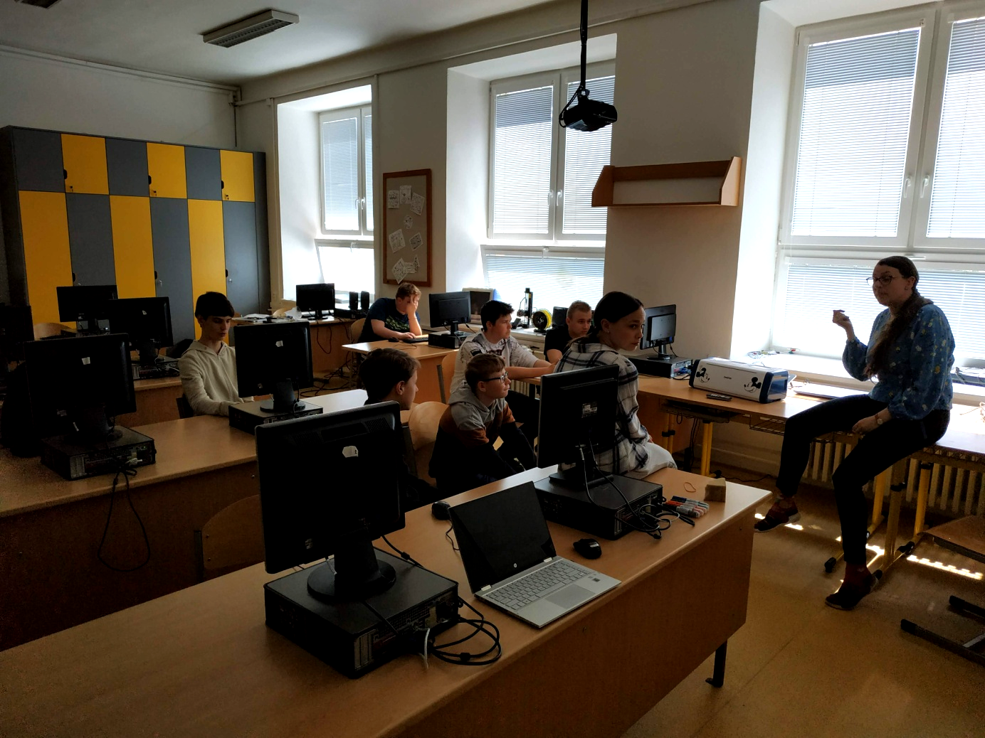

Prototype production (without the use of technology)
- We choose a suitable cotton fabric and trace the cut of the pocket on it with chalk. We choose the size according to what kind of snack we want to carry in it. In our case, it is two slices of bread, or 2 rolls. This means 2 rectangles 17x24 cm on top of each other + rounded pocket flap.

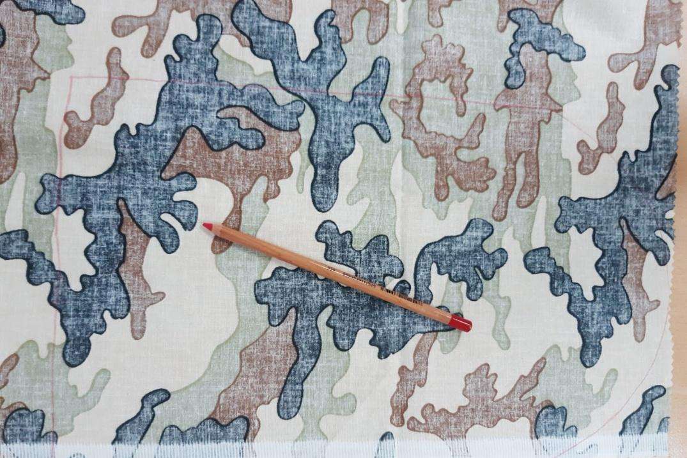

- For the inner washable layer, we need a waterproof food-grade fabric with a PUL coating, on which we trace the same cut as on the fabric.
- We cut out the desired shapes from the fabric and fabric.
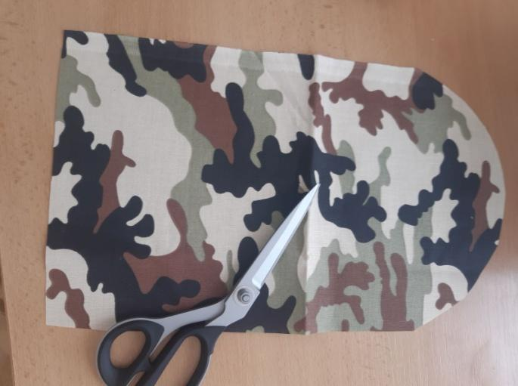

Variant B (monochrome cotton fabric on which we will embroider the logo):
- We will prepare an iron-on lining, which we will iron on the reverse side of the cotton fabric. The underlay must be large enough for the embroidery frame – it must be able to stick there.
- Pin the fabric with the lining to the embroidery frame.
- We convert the sewing machine to an embroidery machine:

  - We slide out the sewing table to the left

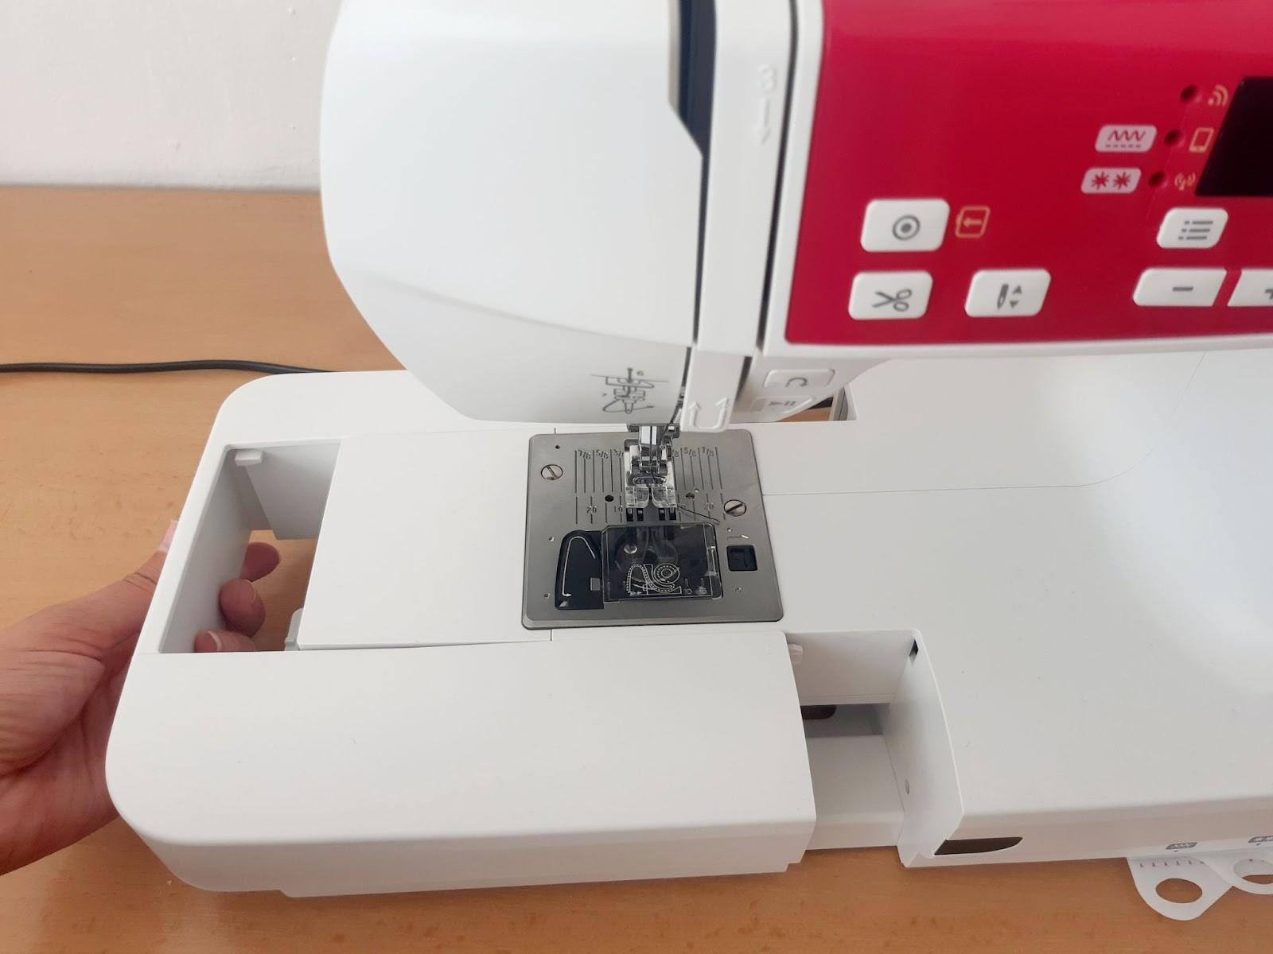

  - Instead, we put on the embroidery unit and click it

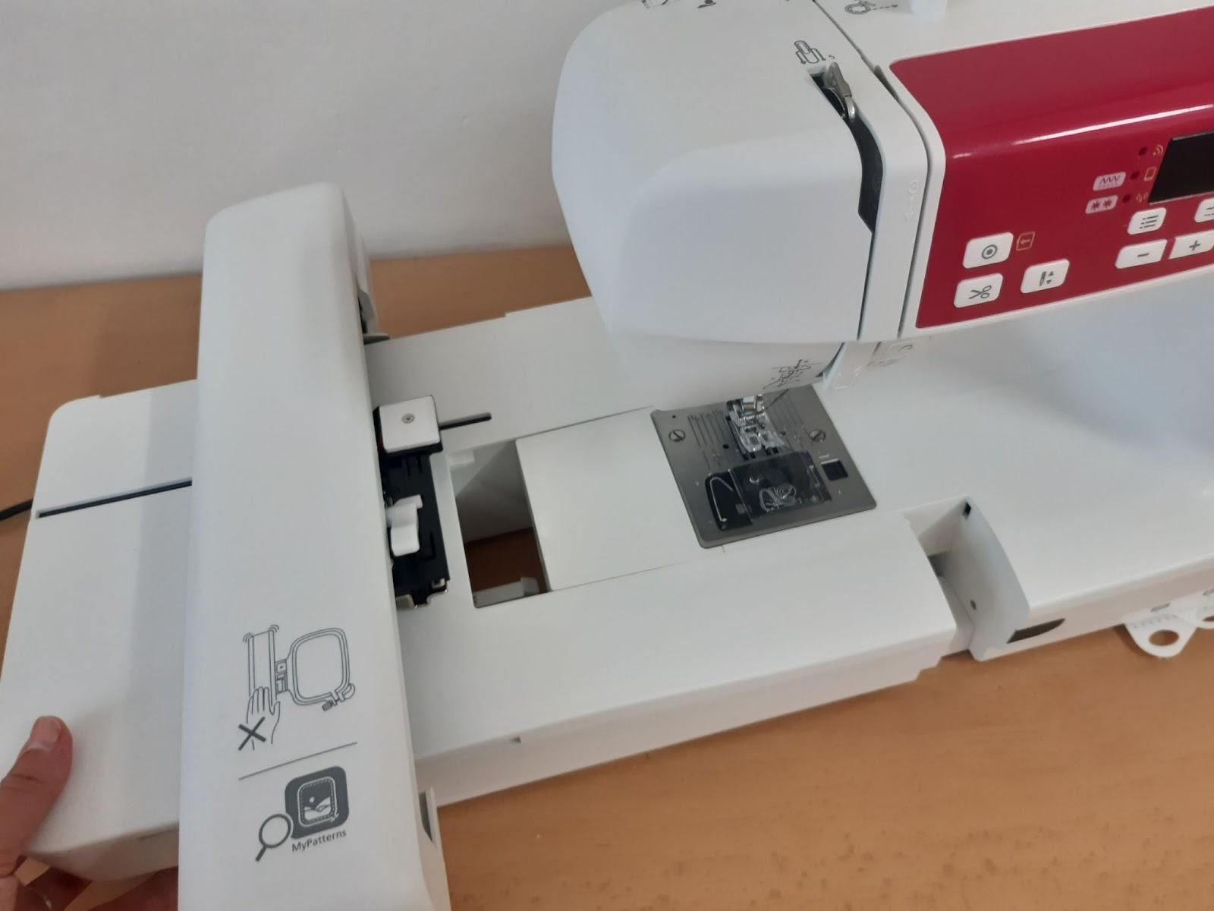
c. Turn off the machine and raise the presser foot lever to the upper position
d. Remove the foot holder
e. Pull out the needle

f. We replace the stitch plate with an embroidery plate

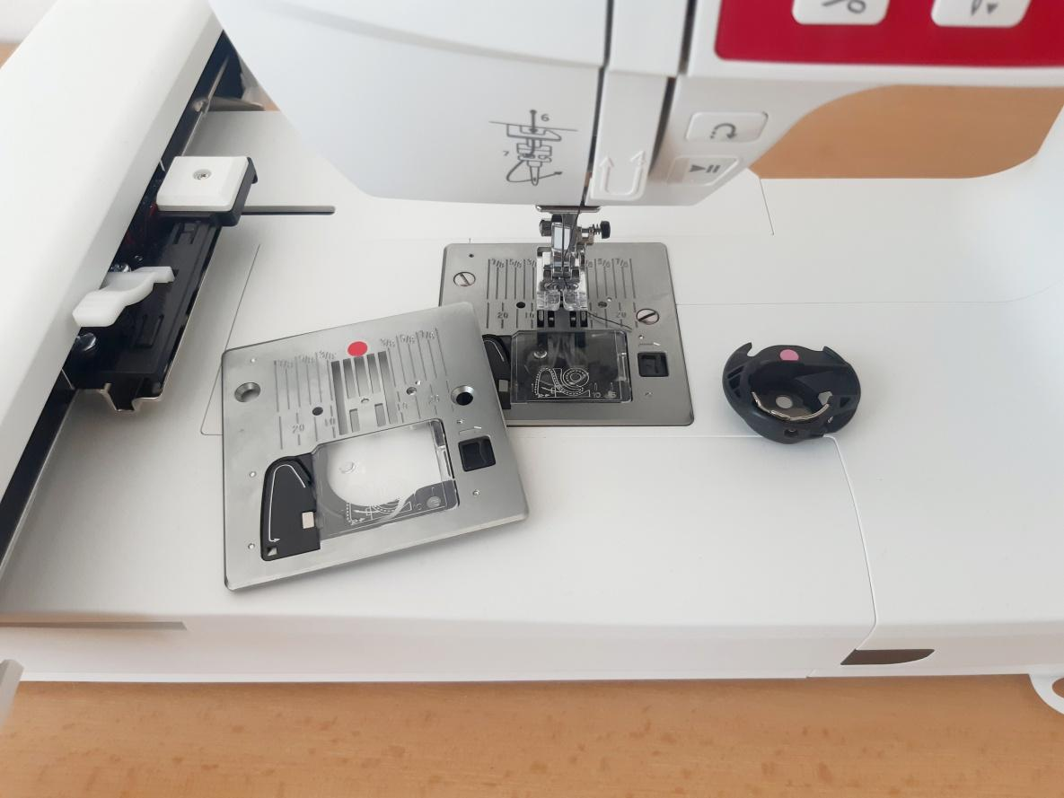

g. We replace the needle with a suitable embroidery one (marked as EMBROIDERY) and insert it into the holder with the side facing away from us. We tighten the screw of the needle holder.

h. We change the embroidery foot

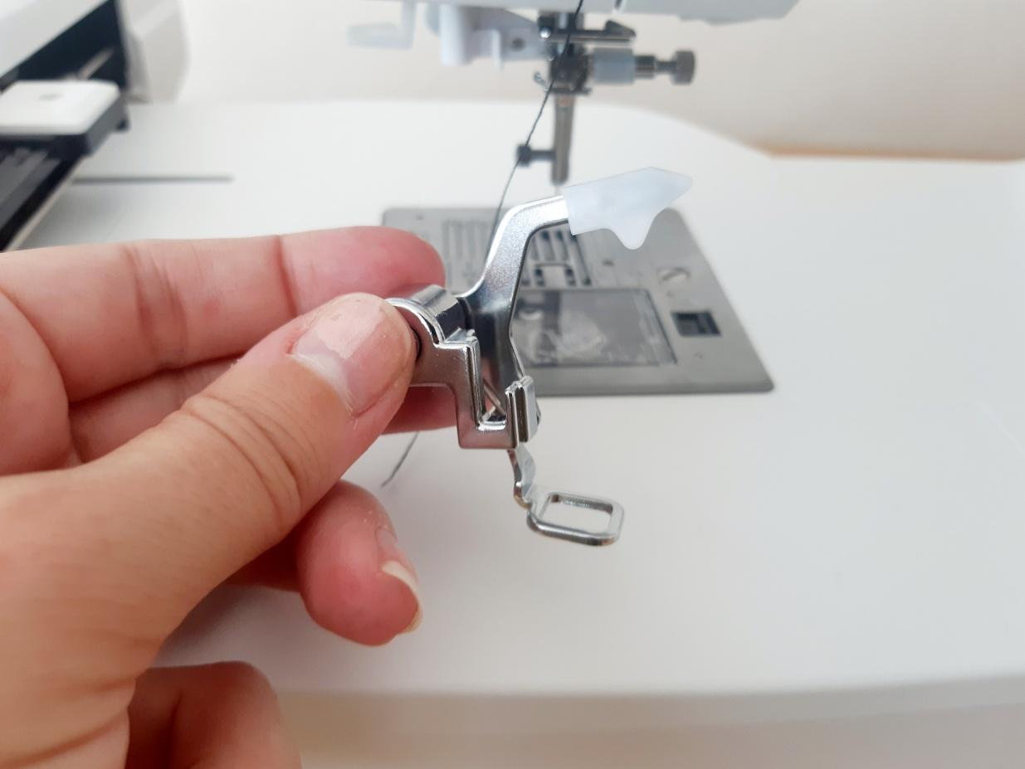

- In the My Patterns application, we will prepare the selected embroidery pattern. We will use a mobile phone or tablet for this.
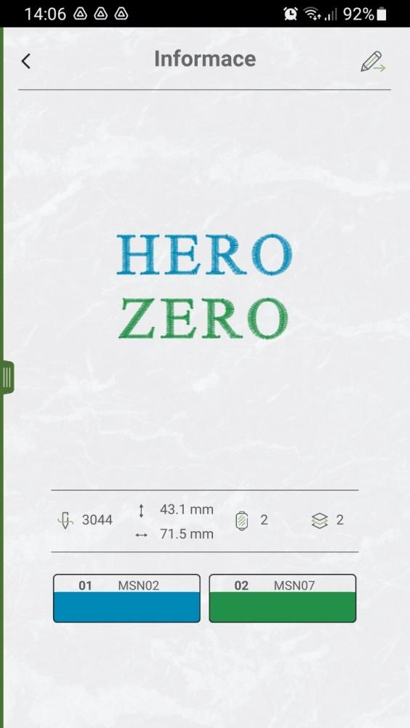

- Connecting a phone or tablet to the sewing machine
  - We switch the machine to the on position and PP is displayed on the machine, at the same time the middle diode of the machine display lights up.

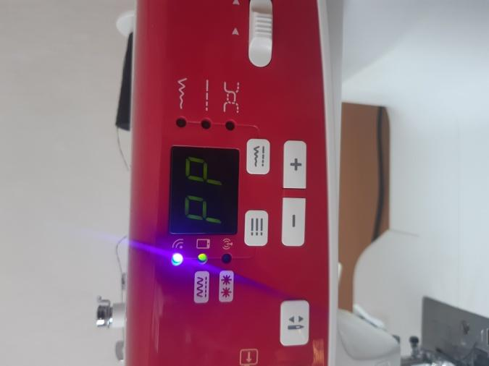
  - The WiFi indicator is flashing = the machine is ready to connect
  - Open the My Patterns application on a mobile phone or tablet, press "Add new connection" in the bar on the left and select "Point-to-point connection settings"

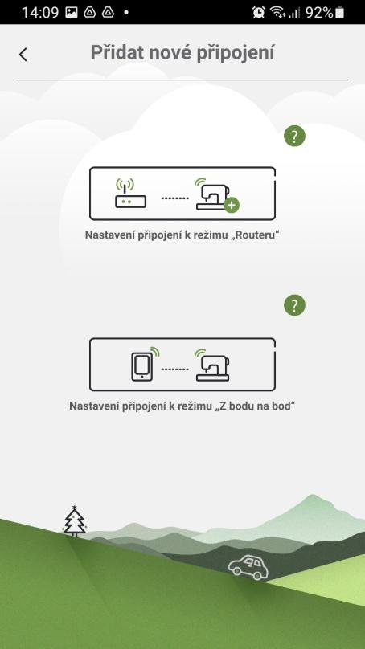

  - The connection will take place automatically and GO will appear on the display. The machine is now ready to embroider.

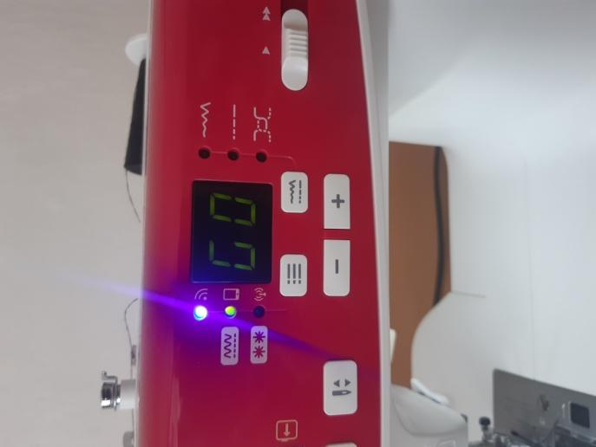
e) We let the mobile application guide us - we connect to the Wi-Fi machine, calibrate the embroidery frame and we are ready to embroider. Thread the embroidery threads. We turn it on with the Play button and the mobile application guides us when to change thread colours, etc.

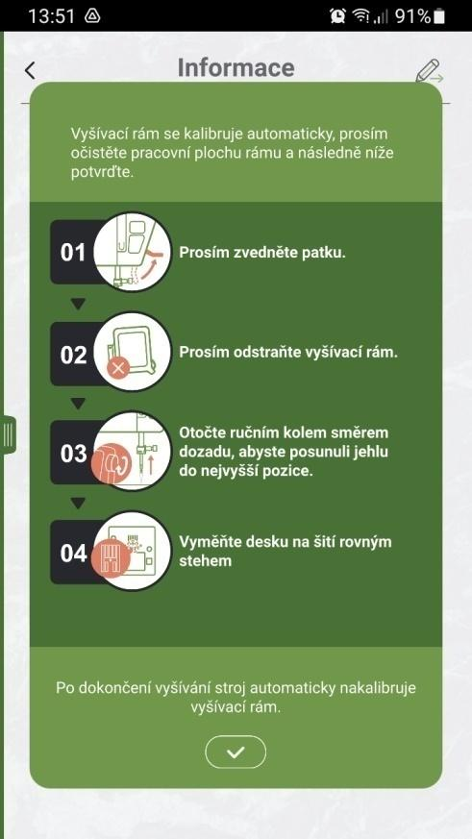

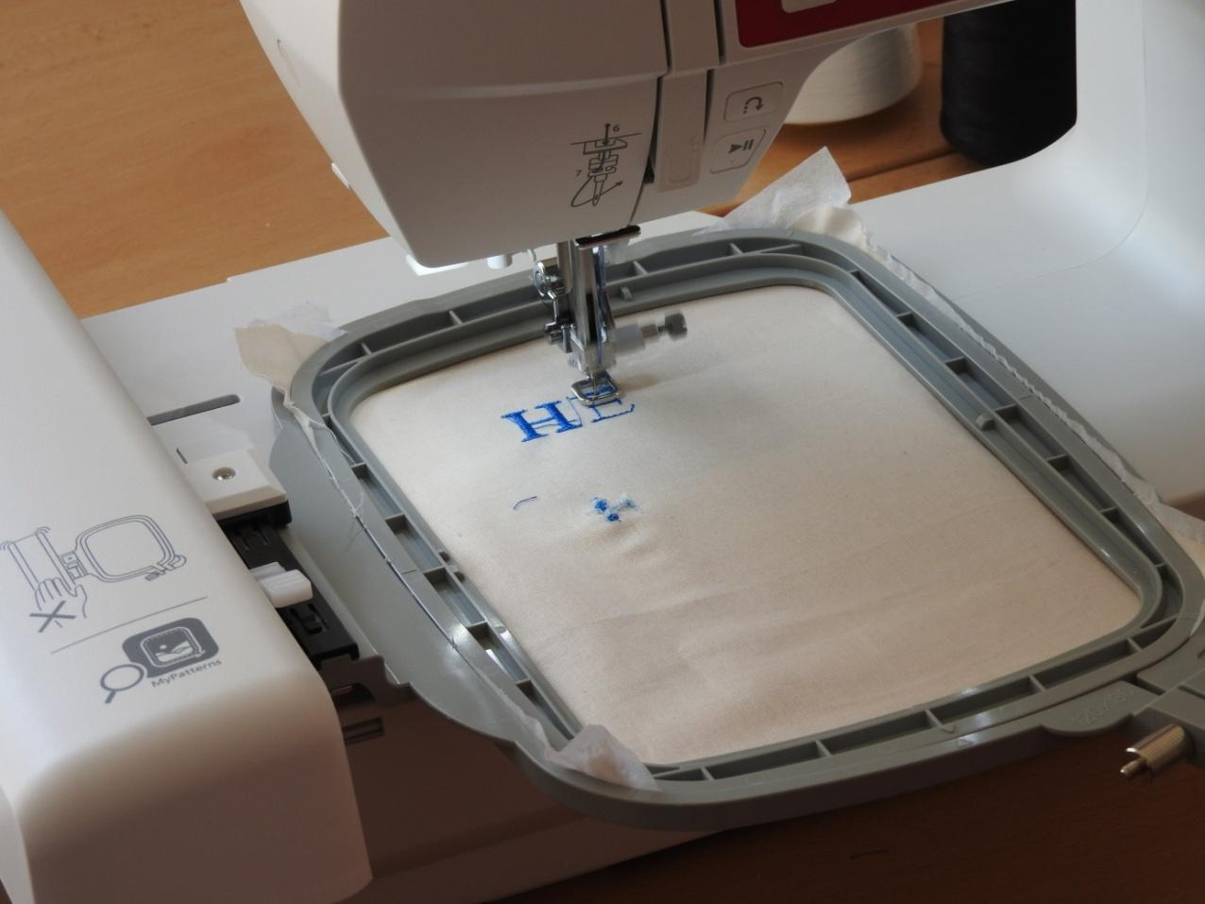
- When we are done, we change the machine to sewing again - changing the stitch plate, presser foot, threads, extending the embroidery unit.
- We will prepare a sewing machine. We turn it on, we check whether we have wound the lower thread. We choose a suitable needle and change it - needles marked UNIVERSAL are enough for sewing cuts.
- We put both cuts on top of each other. We are careful to put them on the right side - the washable smooth layer must be on top, as well as the print of the cotton fabric must be visible if we have chosen a patterned fabric.
- Pin the fabrics together to be sure. We insert the pins at a sufficient distance from the edge so that they do not interfere with us when we sew the fabric.
- We will sew both parts together - we will need an overlock foot E and we will use stitch number 9. When both parts are sewn together, we will fold them into a pocket shape and sew both short sides again.

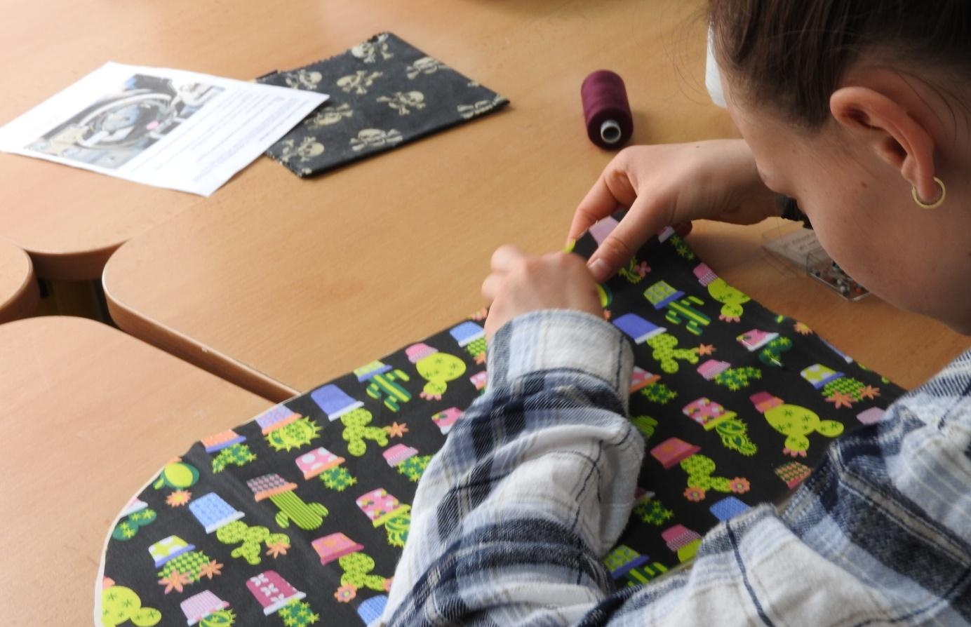

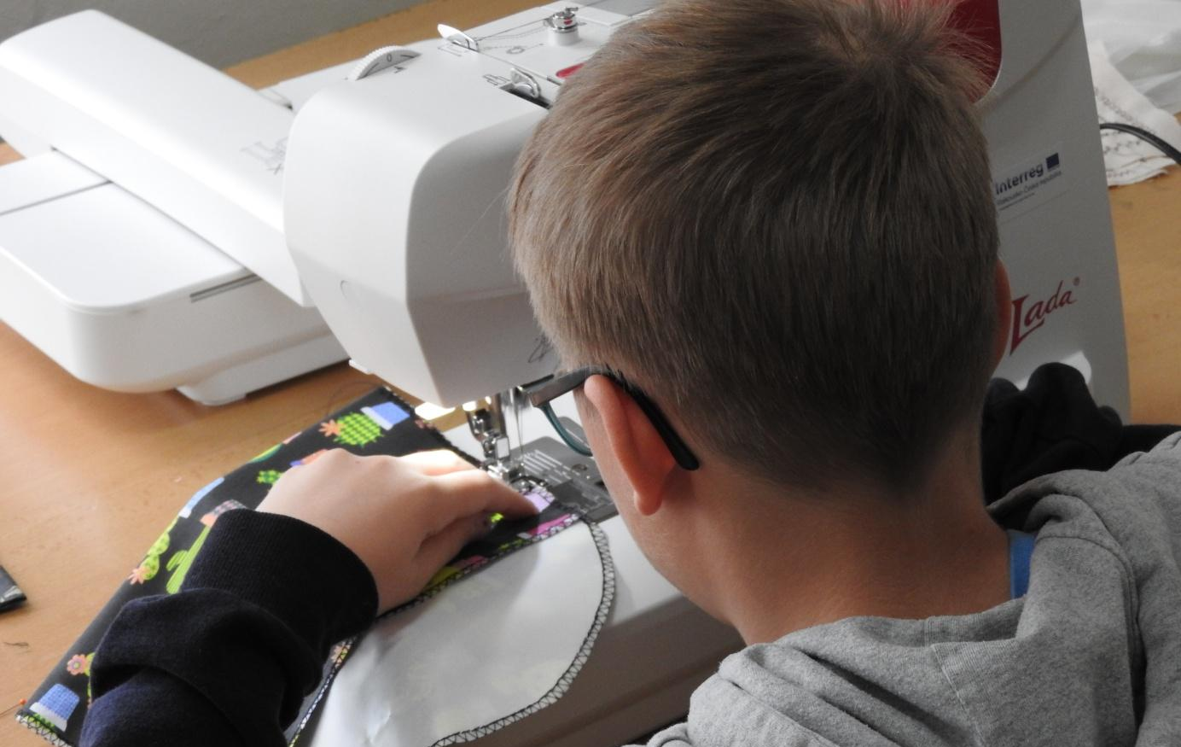

- Now it remains to sew the button and the button loop. We sew the button firmly on the front of the pocket. We will sew the loop into the seam on the pocket flap – we will need an elastic band for this and we will do the sewing by hand with a needle.

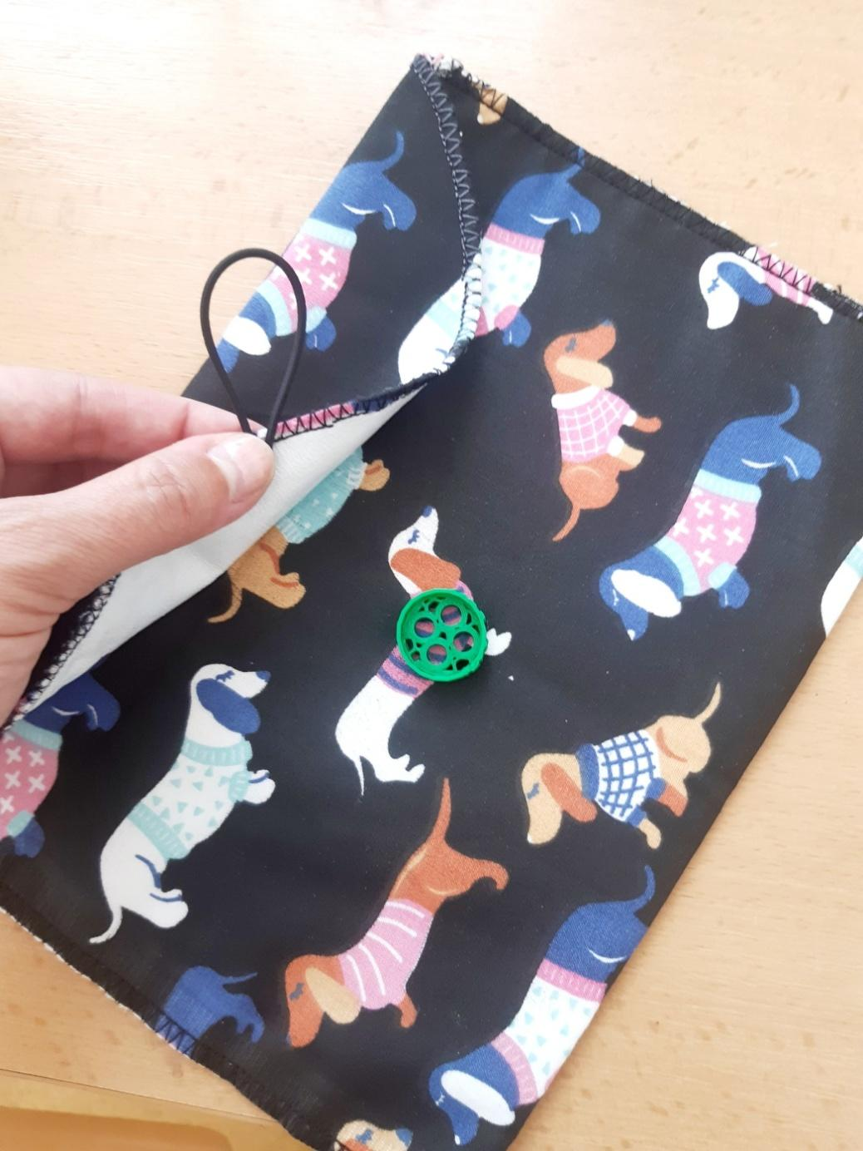

Problem solving – how to incorporate advanced digital technologies into production to increase work efficiency and product attractiveness
This step is shown again with an educational video or a presentation on the topic of digital technology, robotization of production, collaborative robots, elimination of stereotypical work, Industry 4.0. Subsequently, we will evaluate with the pupils what equipment we have available and in which steps of the work procedure it could help us. The following proposal may result:
- the use of a graphics tablet and the Krita program to design the school ecolabel logo,
- converting the cut of the pocket into electronic form - the fabrics will be cut with a plotter,
- scanning the original paper cut (an easier option),
- editing design in the CanvasWorkspace environment,
- replacement of redrawing the cut on fabric and cotton canvas and cutting out with automatic cutting on the plotter pad,
- ecolabel embroidery design using a graphics tablet in the EZDesign program,
- pocket design button design in Tinkercad environment,
- printing a button from PLA on a 3D printer.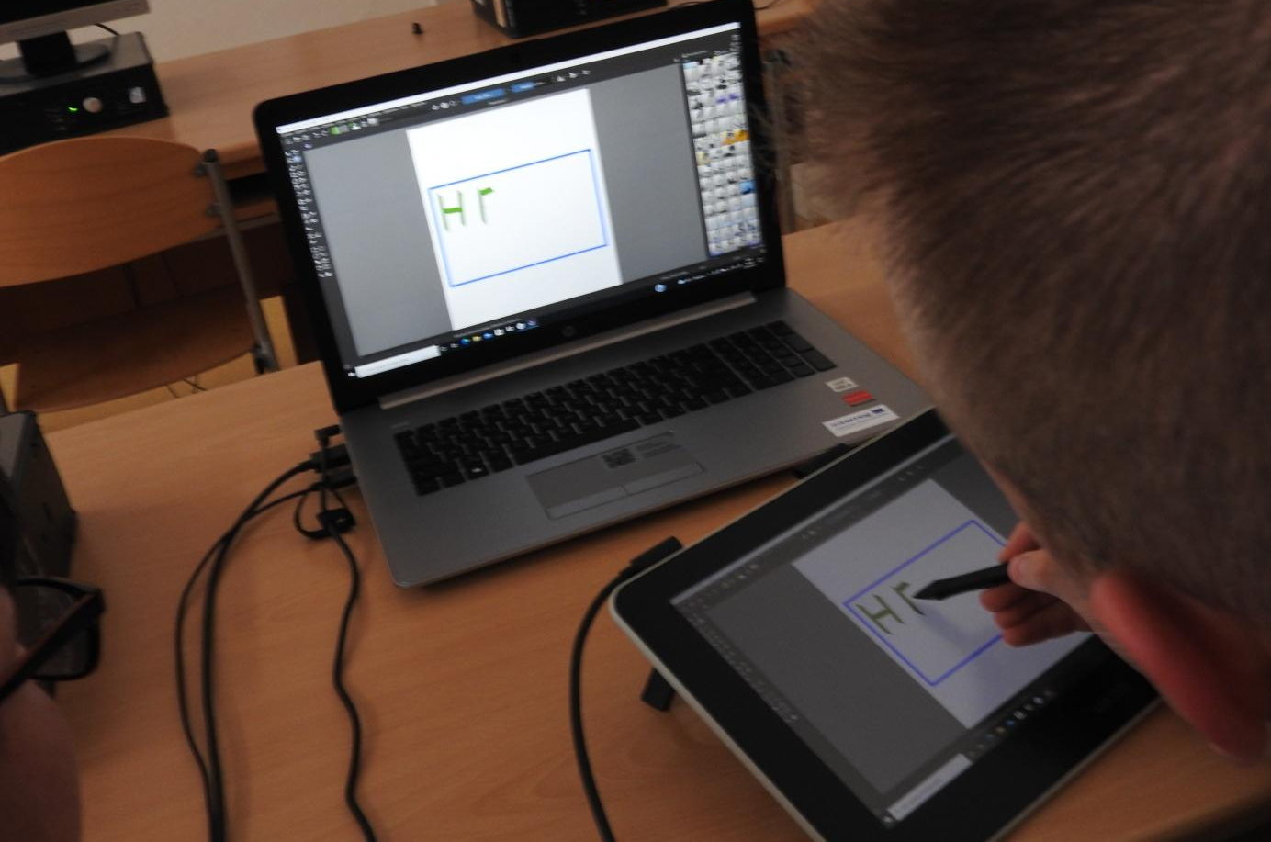

Graphics tablet – creating a logo in the Krita program

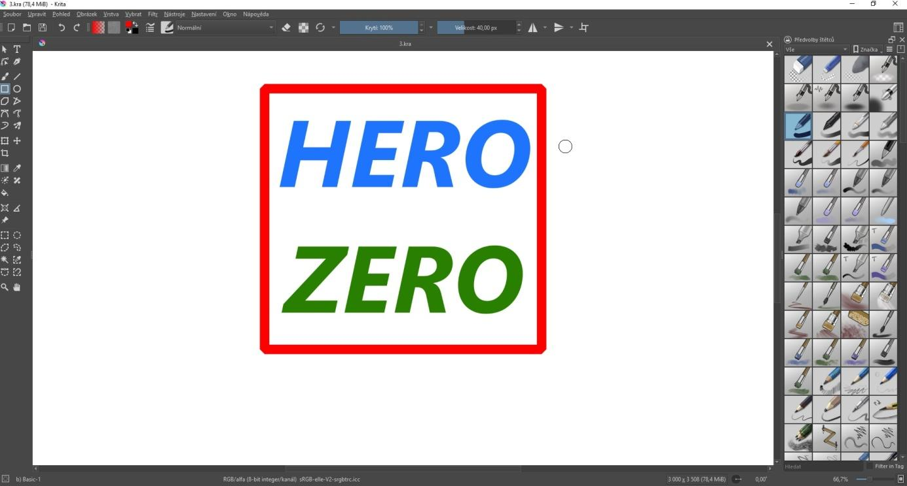
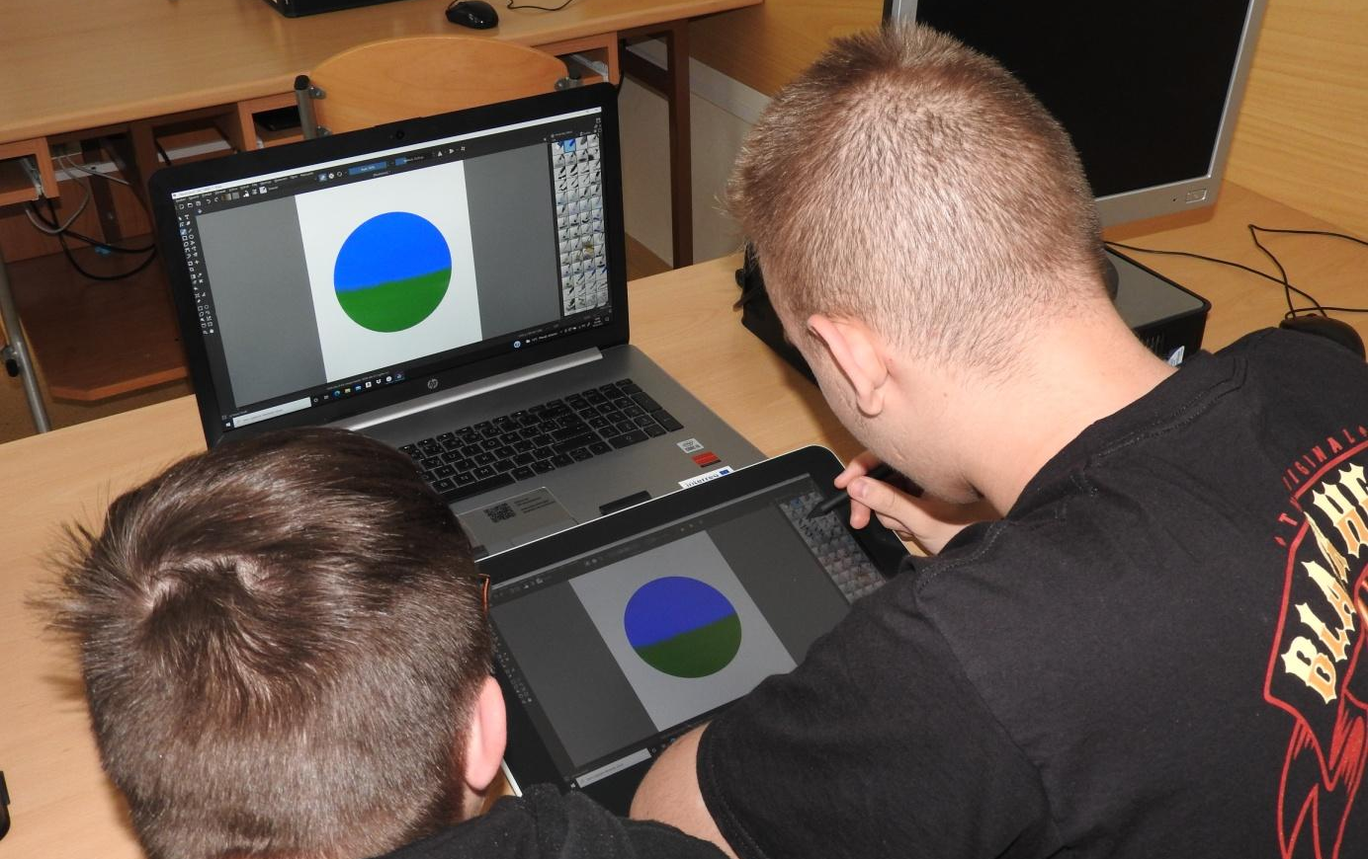

Editing design – CanvasWorkspace environment
Object selection

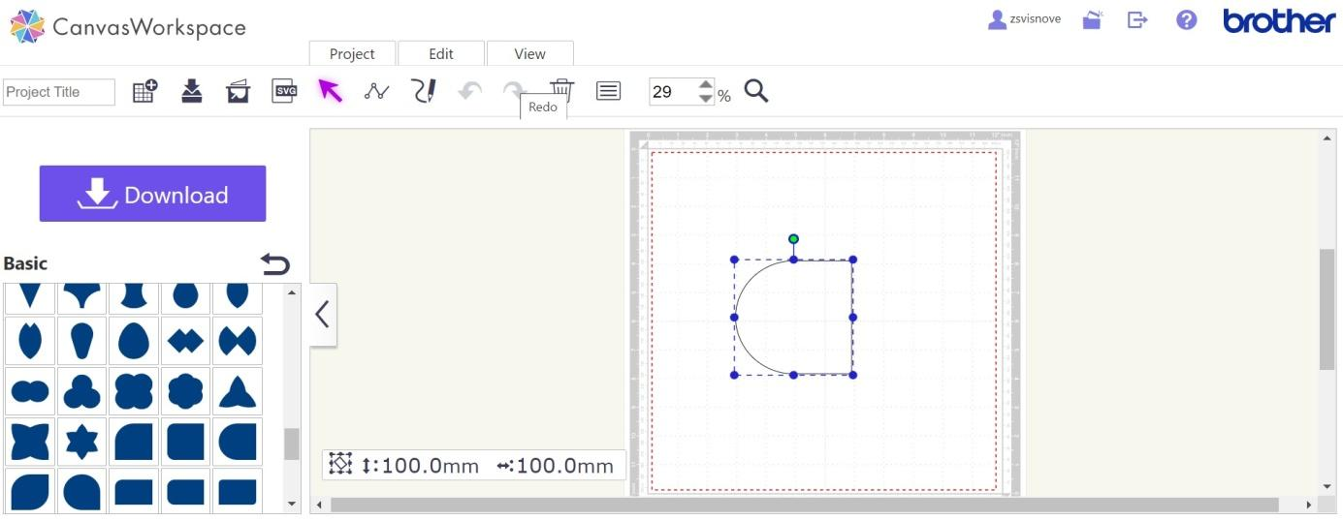
Work with the object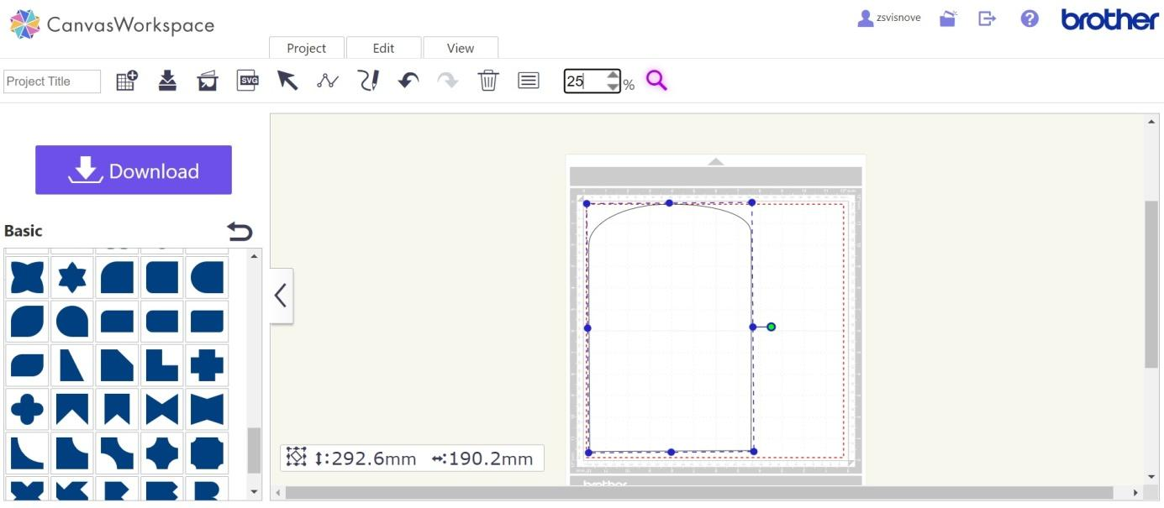
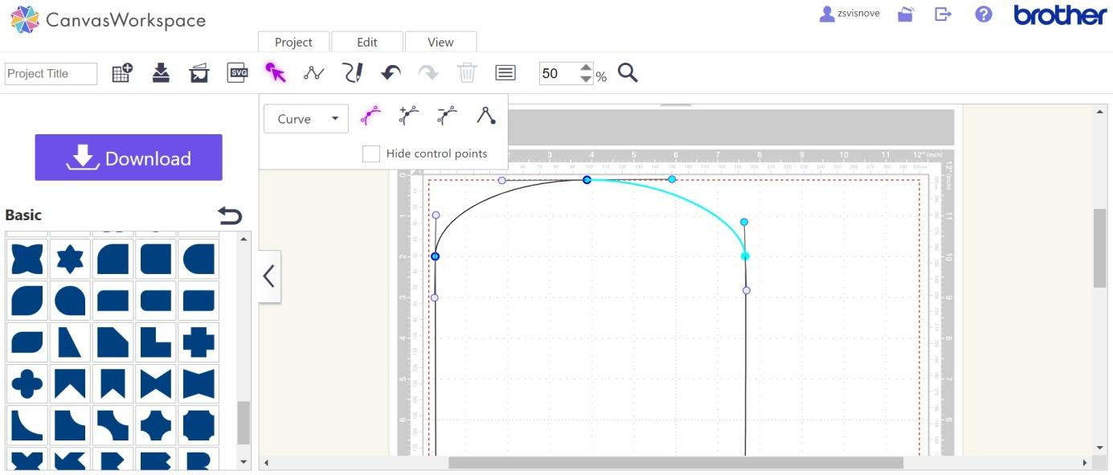

Cutting plotter – scanning cut, cutting fabric and canvas
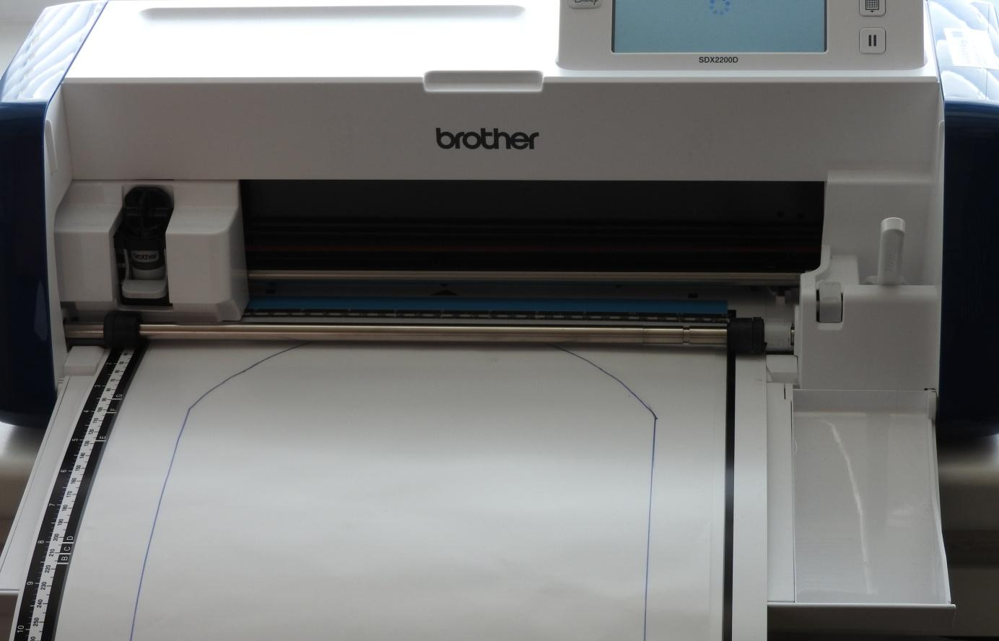
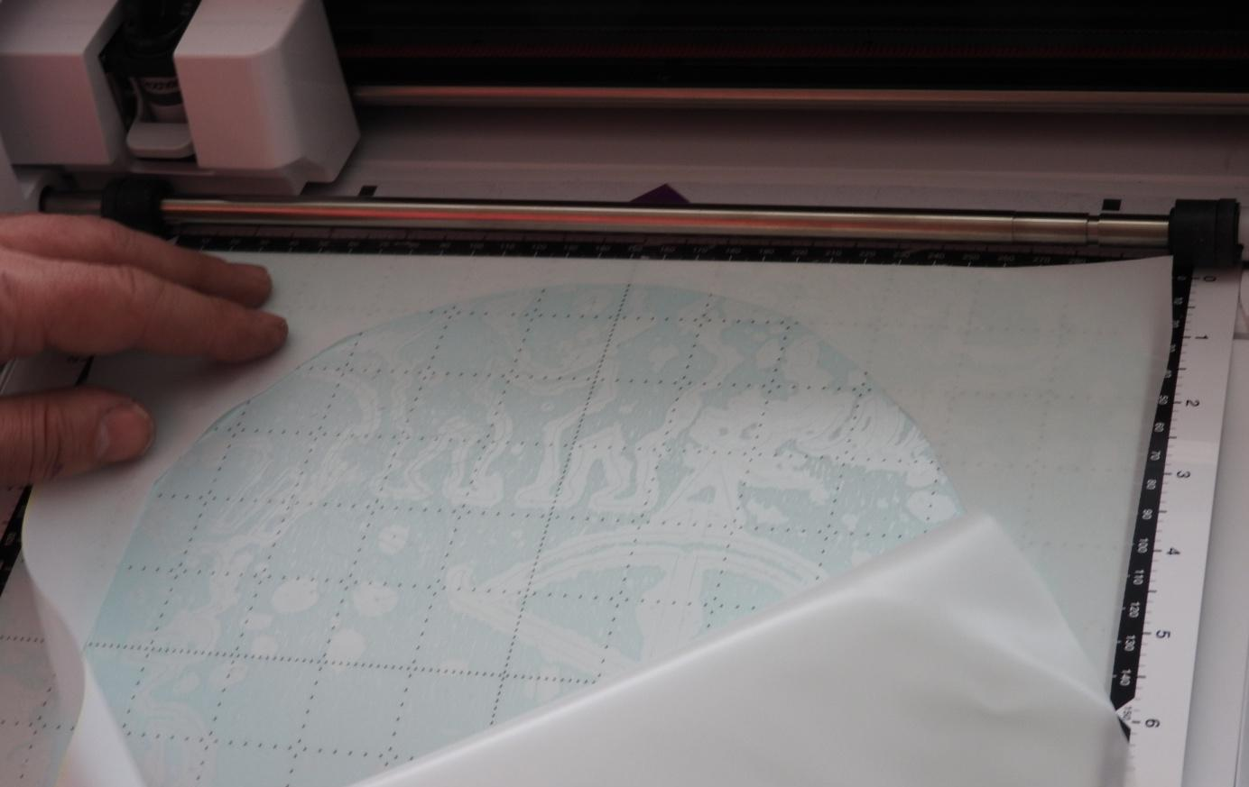

Graphics tablet – embroidery design in the EZDesign program
Creation of objects
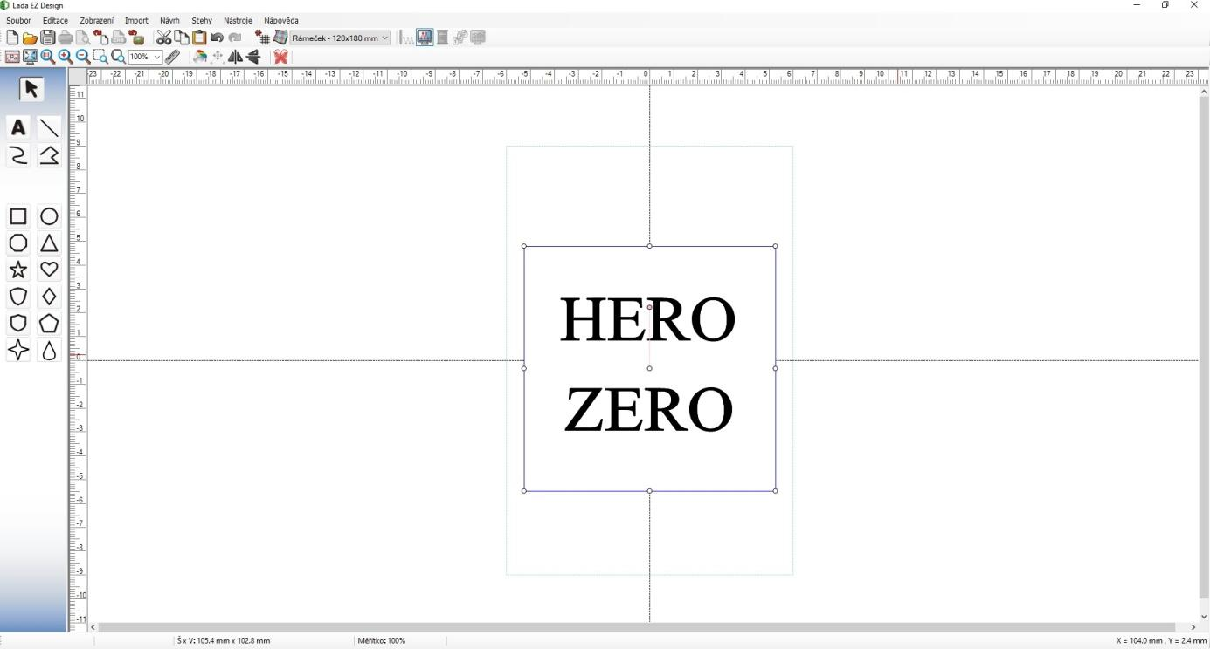
Choosing a stitch for the morning

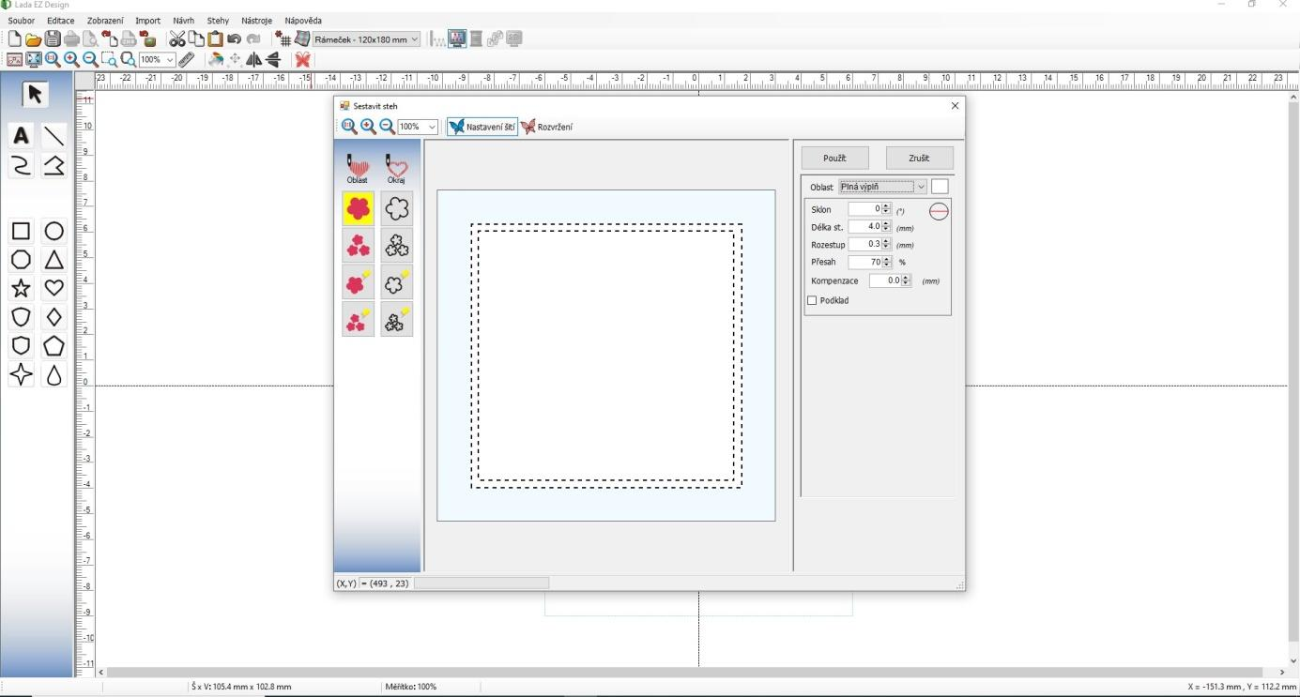
Thread colour settings
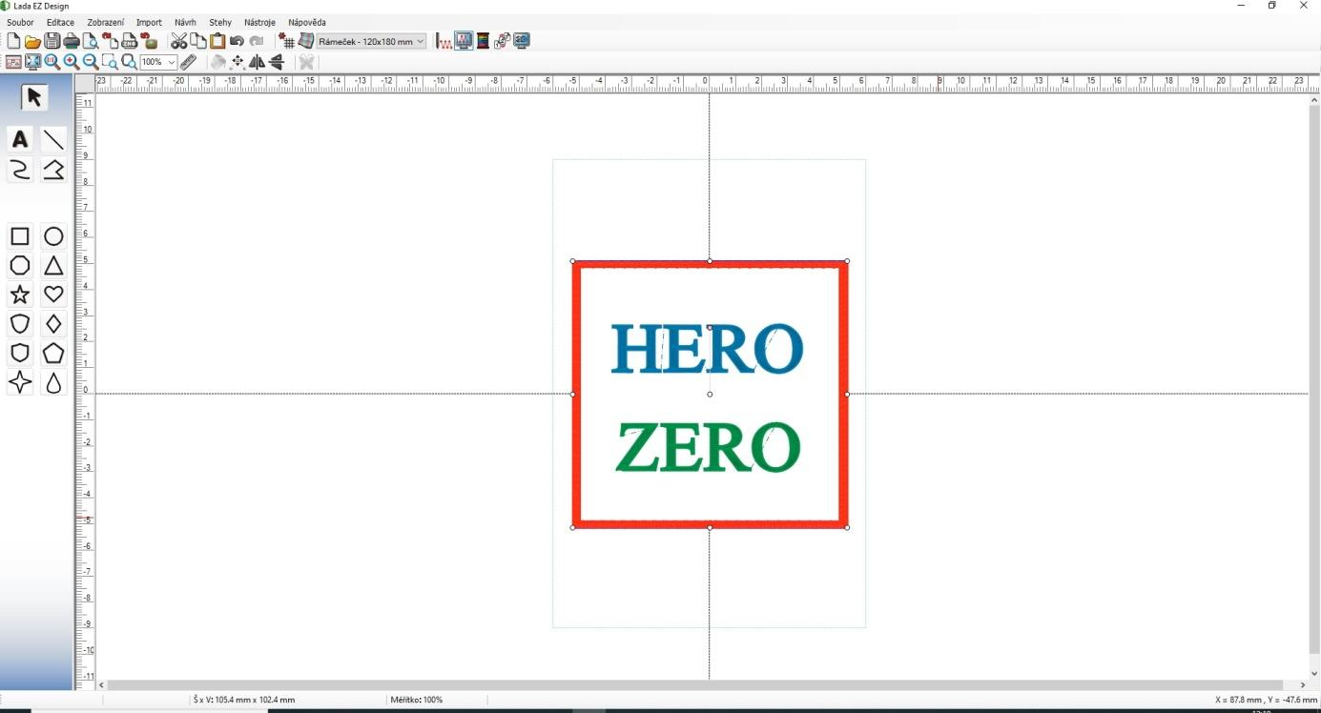
Embroidery simulation
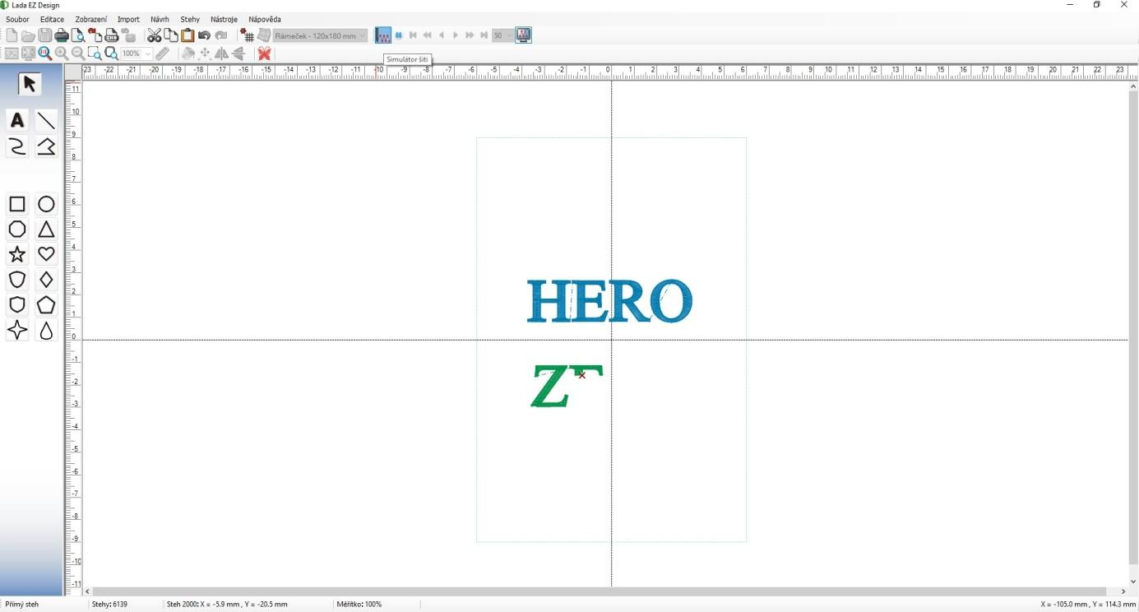

3D printer - button design in Tinkercad environment, slicing in PrusaSlicer, custom printing
Button design proposal
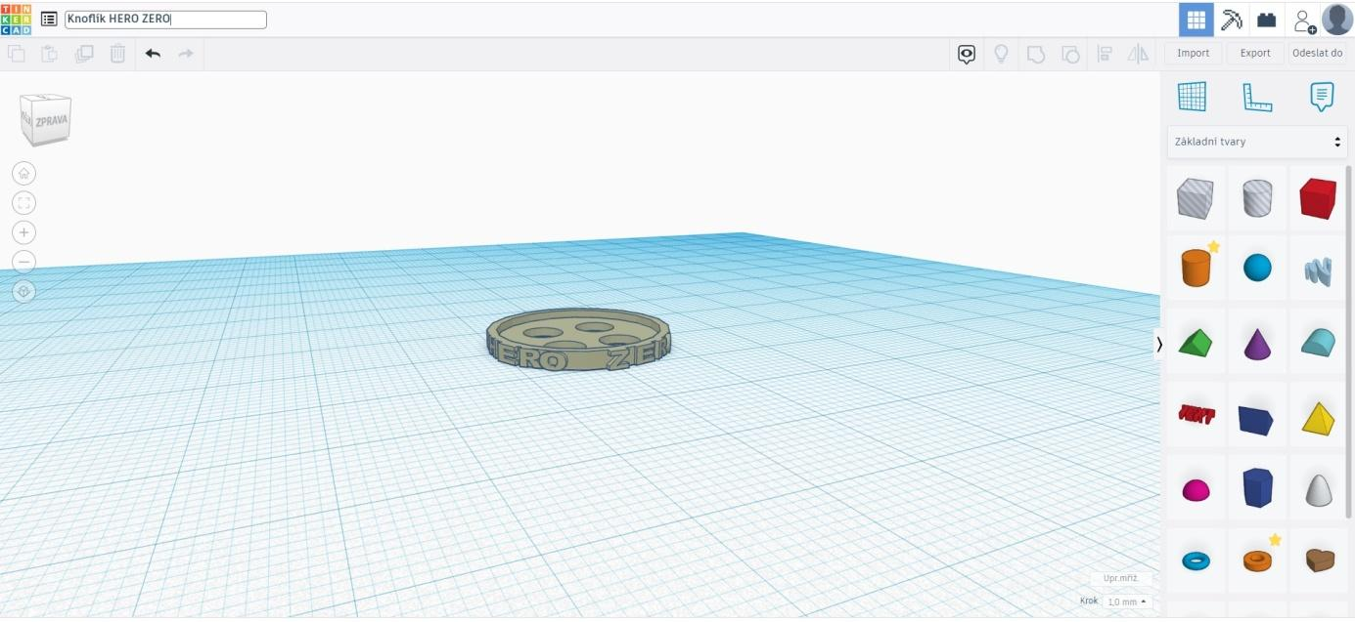
Slicing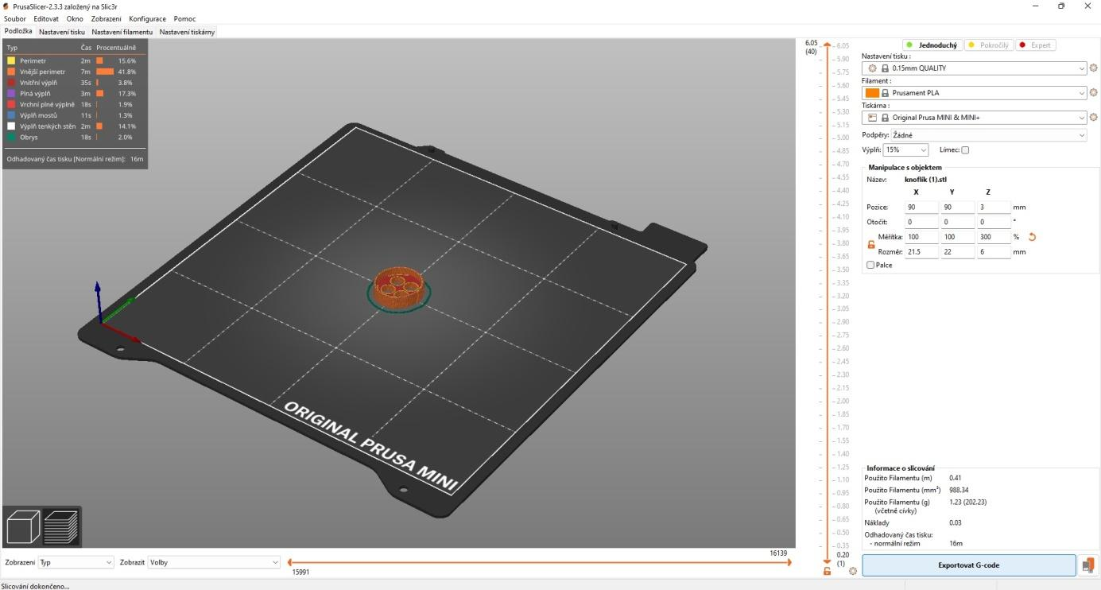

Printing on a Prusa MINI printer
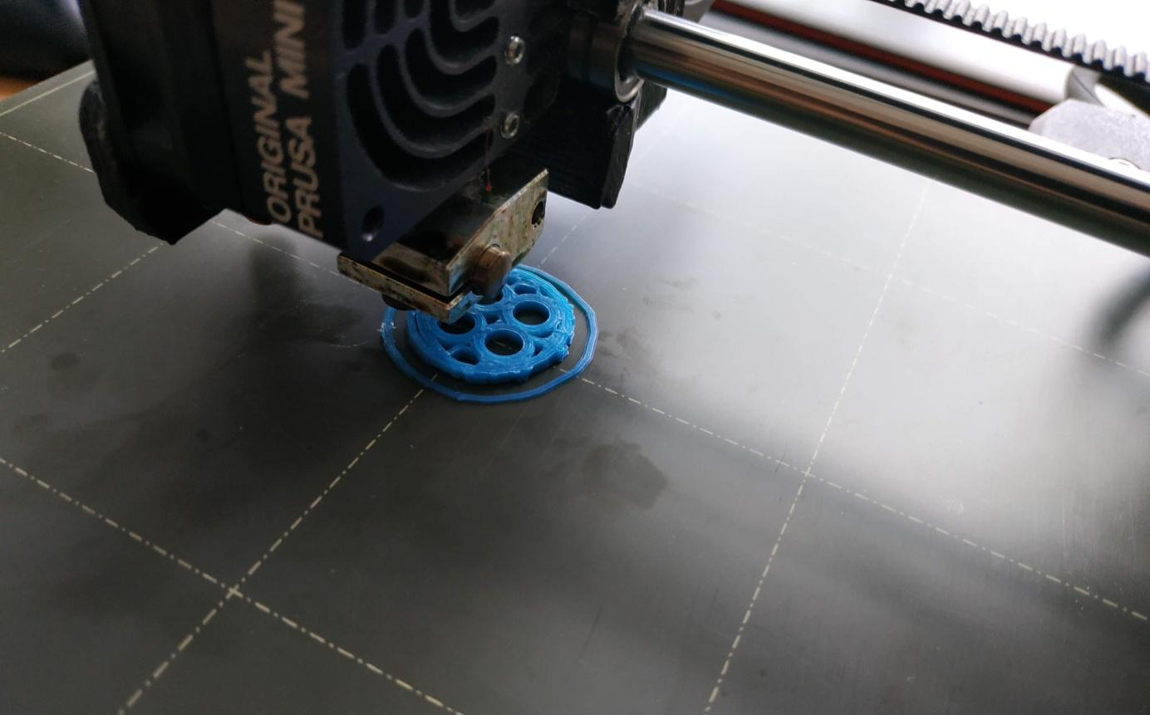
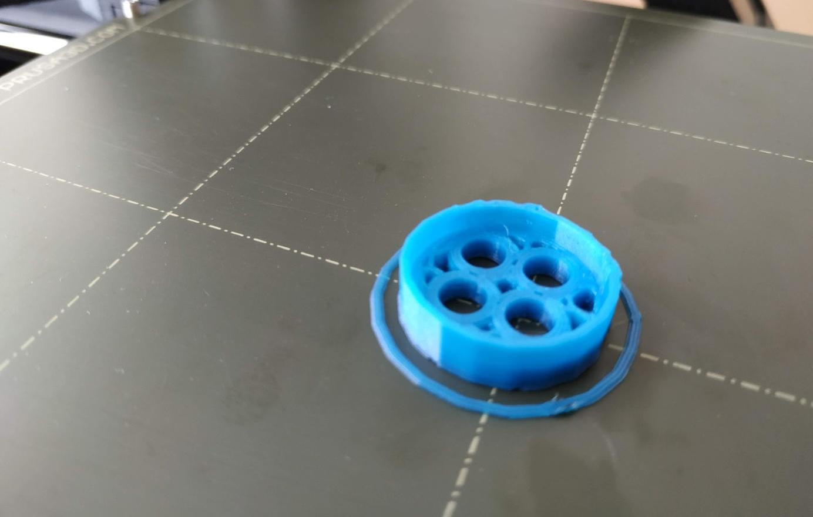

Final product
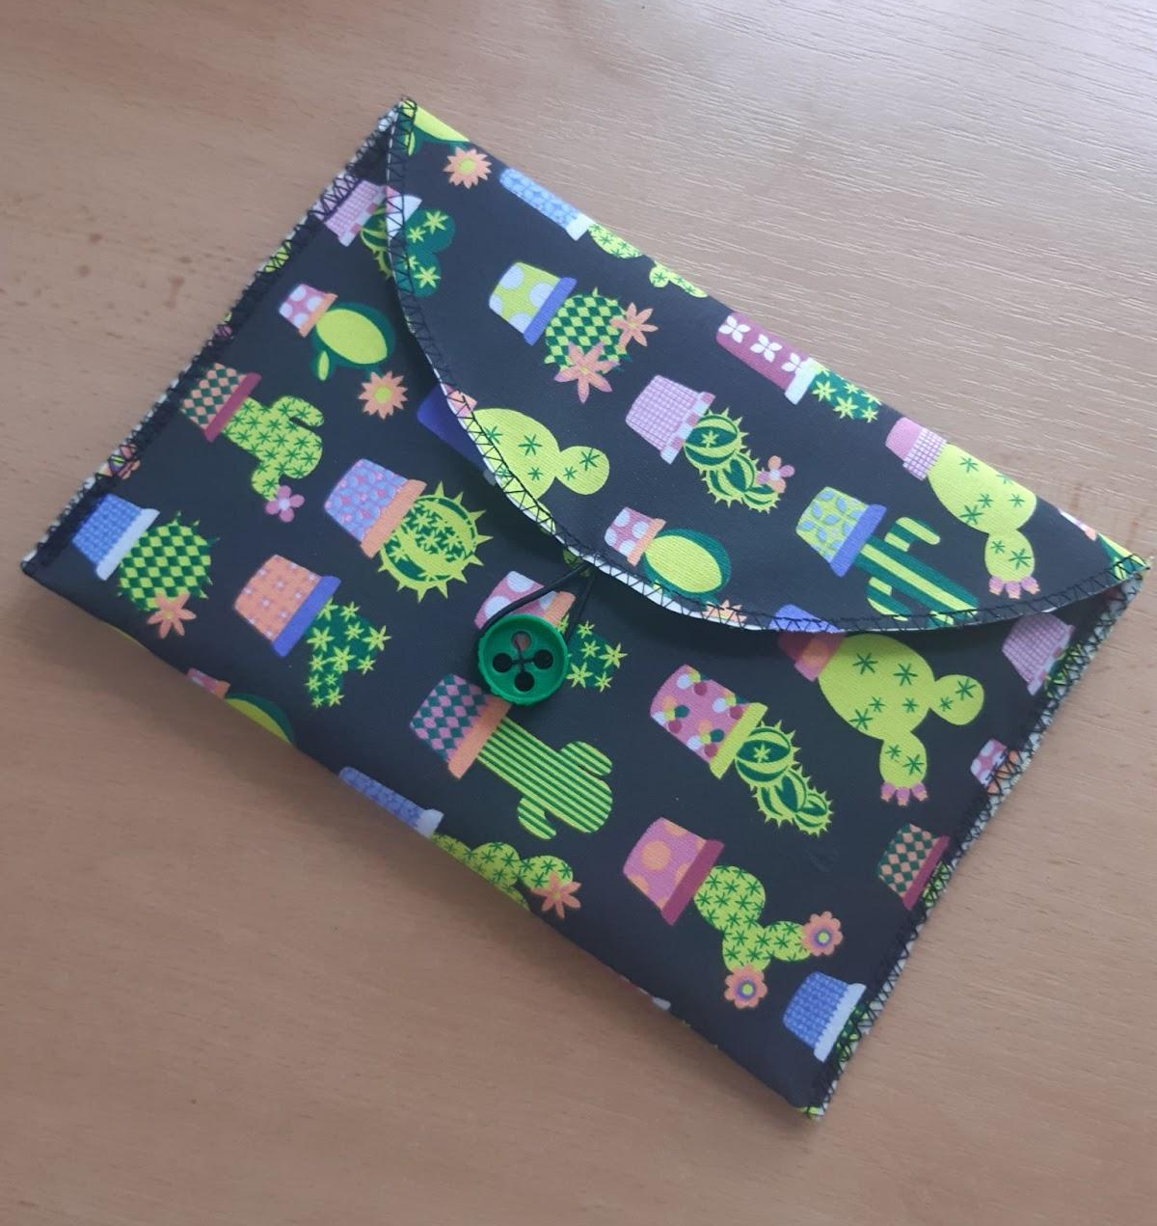

Theoretical background for the implementation of the project
For the successful implementation of the project, it is necessary for the students to familiarise themselves with:
- graphics program Krita
- instructions for using the cutting plotter – scanning functions, cutting various materials, file transfer via USB,
- the manual for the CanvasWorkspace program,
- instructions for the Lada L90 sewing machine – basic sewing and embroidery functions,
- manual for the MyPatterns application
- manual for the Lada EZDesign program
- the basics of working in the Tinkercad environment
- user manual for PrusaSlicer
- 3D printer manual
Familiarisation with the selected requirements can be done by the teacher. Each student does not need to be familiar with everything, but students can profile themselves (operating a sewing machine, creating 3D objects, ...).

List of links to study materials and resources used

Krita user manual: https://docs.krita.org/en/index.html
Cutting plotter operating instructions: https://eshop.brother-czech.cz/rezaci-plotr-brother-scanncut-sdx2200D/
CanvasWorkspace Manual: https://canvasworkspace.brother.com/Help/faqs_en.pdf
Lada L90 sewing and embroidery machine operating instructions: https://www.ladasicistroje.cz/Lada-L90-sici-a-vysivaci-stroj-d228.htm
MyPatterns manual: https://play.google.com/
Lada EZDesign user manual: part of the installation package supplied with the sewing machine
Basics of working in the Tinkercad environment: https://www.tinkercad.com/dashboard
PrusaSlicer manual: https://help.prusa3d.com/cs/article/zakladni-informace_1910
3D Printer Guide: https://help.prusa3d.com/cs/tag/mini

Project outputs
The output of the project is a product – a prototype of a snack bag, which is an alternative to the used microtene bags and the creation of the HERO ZERO school eco-label. To increase the efficiency of pocket production and its originality, the students used many digital devices, which they had to learn to operate, including software. The pedagogues who accompanied the students through the project acquired the same skills. This increased the level of digital literacy of both target groups of the project.
There was motivation thanks to the presentation on the school's website (see links below) and the presentation of the project to pupils and teachers:
- teachers across the school acquired new skills in digital literacy,
- pedagogues got to use new devices in the preparation of teaching itself,
- pupils chose an optional polytechnic subject in which they will work in our digital workshop (4x increase in interest), students dealt with the issue of sustainability of human activity and its impact on nature (o rganisation of zero waste events under the new school ecolabel HERO ZERO).

Links to the project presentation – articles from the school website

https://www.zsvisnove.eu/?p=6507
https://www.zsvisnove.eu/?p=6738
https://www.zsvisnove.eu/?p=7594
https://www.zsvisnove.eu/?p=7620
https://docs.google.com/presentation/d/e/2PACX-1vSgrd9hfP1LUbt9ih3PRVR55V2874lYN0qtYStbYWxtuOGr4LiTz63AzKIzofw2AA/pub?start=true&loop=false&delayms=3000&slide=id.p1

Summary of work

The implementation of the Digital Heroes student project fulfilled the project's goals, namely:
- preparing pupils and teachers for life and work in a digital society.
- the development of pupils' digital literacy,
- supporting their critical thinking,
- improving the digital skills of teachers.
The students proved that modern technologies can help ensure the sustainability of human activity and contribute to environmental education not only in schools.

